PLEASE SUBMIT TO:

Fostoria Area Habitat for Humanity
PO Box 607
Fostoria, Ohio 44830

PHONE: 419-435-2844
EMAIL: info@fostoriahabitat.com
Website: www.fostoriahabitat.com

Application’s Open Year Round and Reviewed Quarterly
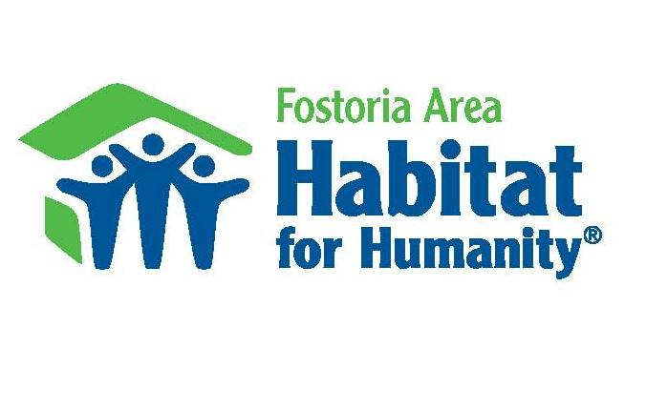

FUTURE HABITAT HOME OWNER
PRE - APPLICATION FORM 6.19.17 rh

Dear Applicant:

Thank you for your interest in owning a Habitat for Humanity Home
There are three REQUIREMENTS to apply for a Habitat home.

- Your current housing situation must be substandard (see page 2).
- Your family’s gross income (before taxes) must be below the 80% HUD Income Guideline of Family GROSS INCOME according to Family Size.

HUD Income Guideline
Fostoria Area
FAMILY SIZE YEARLY GROSS INCOME
Minimum Max
One (1) 12,150 37,000
Two (2) 16,240 42,250
Three (3) 20,420 47,550
Four (4) 24,600 52,800
Five (5) 28,780 57,050
Six (6) 32,960 61,250
Seven (7) 35,750 65,500
Eight (8) 38,050 69,700

- You must be willing to partner with Habitat and provide 250-500 hours of "sweat equity" (volunteer hours) to the organization.
Please answer the questions on this form and submit to the Habitat office. Habitat will review the information and contact you about the next steps in the application process. This will include submitting additional information and documentation.

If you DO NOT meet Habitat requirements, you will be notified within 90 days.

NOTE: Providing false information will immediately disqualify you.
BACKGROUND:
How did you hear about Habitat? What person/agency referred you?

Have you ever applied for a Habitat House? YES NO

If Yes, When
If No, What was the reason you were given for being declined?

Have you ever owned a home? ______YES _____NO
If YES, when? __________________________________________________________

HABITAT REQUIREMENTS

1. SUBSTANDARD HOUSING
a. Do you own or rent your home? _____ OWN _____ RENT
b. Number of adults living in your current home:
c. Define the children (17 and younger) living in your current home:

- Age Sex (M/F)
- Age Sex (M/F)
- Age Sex (M/F) No Children
- Age Sex (M/F)
- Age Sex (M/F)

d. Number of bedrooms in your current home:
e. Check problems in the current home: (Check all that apply)

_____ leaking or faulty roof
_____ faulty electrical wiring
_____ heating problems
_____ plumbing problems
_____ structural issues (foundation sinking, floors settling, etc)
_____ unsafe neighborhood
_____ other safety issues Explain:
- INCOME AND ABILITY TO PAY (**answering Yes or No below does not
automatically deny your application)
- Have you filed for bankruptcy in the last two years? ___YES ___NO
- Do you pay your rent on time? ___YES ___NO
- Do you pay your utility bills on time? ___YES ___NO
- Are you currently taking educational classes? ___YES ___NO
- Do you currently have a court ruling (called a judgment/lien)
against you for an unpaid debt? ___YES ___NO
- Do you have any payments that you are making to a
collection agency? ___YES ___NO

If YES, total balance due on debts in collection $

What is your gross (before taxes) yearly income? $_______________

Please list all sources of income. (Include social security, disability, food
stamps, and child support, if reliable and regular monthly payments).

SOURCE OF INCOME per Month GROSS AMOUNT per Month

Example: Whirlpool (Job) $1250.00/month

___________________________ $________________________

___________________________ $________________________

___________________________ $________________________

___________________________ $________________________

___________________________ $________________________

___________________________ $________________________

TOTAL PER MONTH: $ _______________

MUST BE BELOW the 80% Hud Income Guideline of gross family income according to family size on page 1

Habitat for Humanity Mission Statement
Seeking to put God’s love into action, Habitat for Humanity brings people together to build homes, communities and hope.

3. WILLINGNESS TO PARTNER WITH HABITAT

a. I am able to provide 250-500 hours of "sweat equity". ___YES ___NO

b. I am able to attend Homeowner education classes. ___YES ___NO

c. I am willing to attend Dave Ramsey
Financial Peace Courses before I get my home. ___YES ___NO

SIGNATURES: By signing this, you are giving Habitat for
Humanity permission to conduct a
background check and a credit check.

APPLICANT’S NAME:

ADDRESS:
Street City Zip

DATE OF BIRTH: / /

PHONE NUMBERS: HOME:

WORK: CELL:

EMAIL:

MARITAL STATUS: ___SINGLE ___MARRIED __SEPARATED

SOCIAL SECURITY NUMBER:

ARE YOU A UNITED STATES CITIZEN? _____ YES _____ NO

APPLICANT SIGNATURE: X:

DATE: _____________

CO-APPLICANT’S NAME:

ADDRESS:
Street City Zip

DATE OF BIRTH: / /

CO-APPLICANT (continued)

PHONE NUMBERS: HOME:

WORK: CELL:

EMAIL:

MARITAL STATUS: ___SINGLE ___MARRIED __SEPARATED

SOCIAL SECURITY NUMBER:

ARE YOU A UNITED STATES CITIZEN? _____ YES _____ NO

CO-APPLICANT SIGNATURE: X:

DATE: ___________

Please take this completed pre-application to:
FOSTORIA AREA HABITAT FOR HUMANITY
339 Sandusky St Fostoria, Ohio 44830 (419) 435-2844

